Tetrate  
**Learning Hub App Review**

**Design Feedback:**

* If it is a separate page please add our logo and navigation on header.
* Use our brand color (Strong and Flat Color Theme)
* UI design is not impressive. We should improve more.
* UI interaction is also needed to improve
* The resource list should be identified by type. We can add a label or icon (Ex: Video Play Icon, Document Icon… etc.,).
* Add image with the title for resources. It will give more visual feelings.

**Sample resource format:**Resource Type, Title, and Cover Image.  
  
  
  
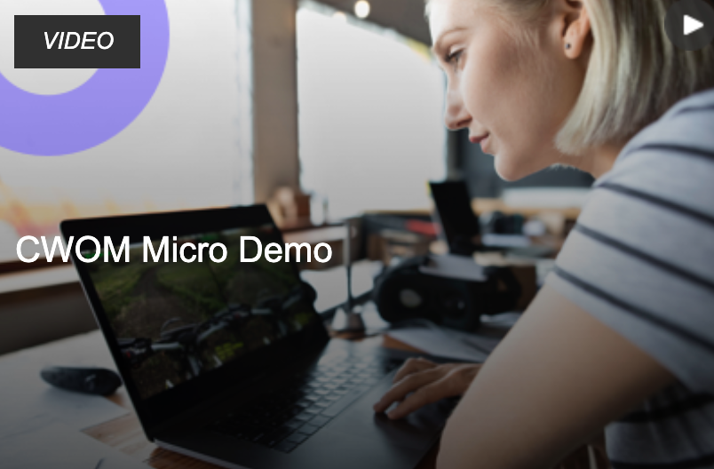  
  


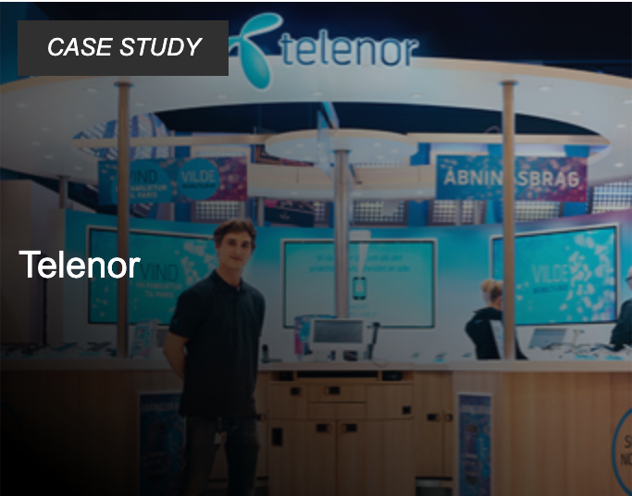

**Add a Title for this page and few Lines Intro Content**   
  
**Ex Title:**  
Resource Center / Learning Hub.

**Ex Intro Content:  
“**Learn more about our products and the benefits we deliver.”  
  
So users can understand the exact purpose of the page.

**Add Filters**

Please use some components (Dropdown, List box, etc..) for filter functionality instead of direct CTA filters (Button). It will be more understandable and user friendly. We can expand content with components.

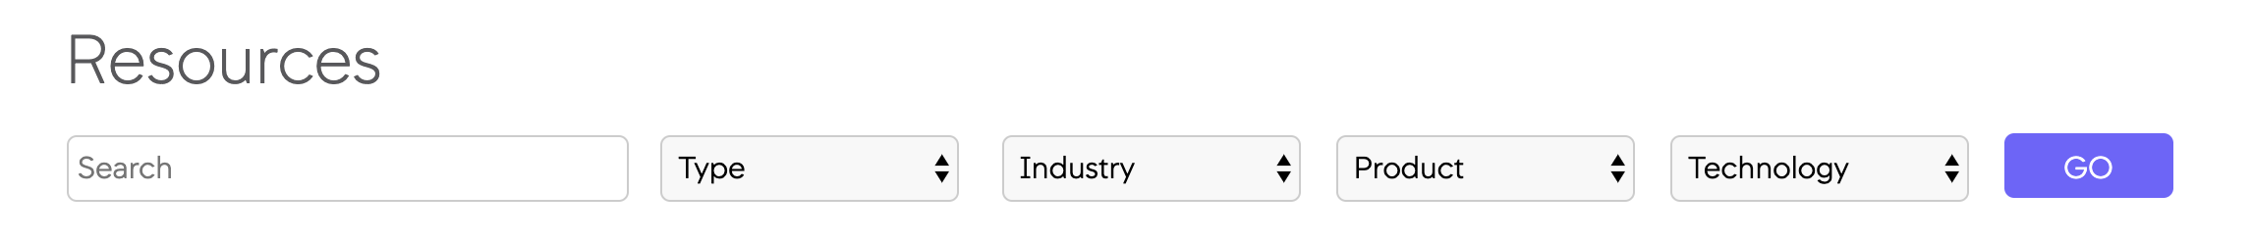

* Technology / Topic / Products
* Type
* Industry
* Search

**Technology / Topic:**

* **Tetrate Service Bridge**   
  + TSB
  + Istio
  + Envoy
* **Istio**   
  + Istio?
  + Install & Upgrade
  + Debugging
  + Recipes
* **Envoy**   
  + Envoy?
  + Install & Upgrade
  + Debugging
  + Recipes

**Type:**We should define the resource type clearly. So users can go and select what they want.

* Video
* Demos
* eBook
* Datasheet
* White Paper
* Webinar
* Report
* Case Study
* Reviews
* Infographics
* Solution Briefs

**Industry:**

We can add some industry lists based on our customers.

* Communication
* Education
* Financial Services
* Government
* Healthcare
* Manufacturing
* Telecom

...etc.,

**Search:**Our resource sections will be increased always. So technical people prefer to use search filters to get their resources.

**Resource Navigation Suggestions**

Please don’t open the resource page in a separate tab. Open to the same page. It will help to reduce the bounce rate.

1. YouTube Videos:  
   Don’t give direct YouTube links. Insert embed code into our page.  
   * Embed code will reduce bounce rate
   * We can track video visitor with Google Analytics
   * We can track CTA click
   * Helps to understand user interest
   * With Google Analytics data we can identify most popular videos
2. Links (Webpage / Blog / Article ...etc.,)  
   Change URL target attribute _blank to _self. Don’t open website related links in the new tab or blank window.
3. If possible please open PDF links into Iframe. So we can track PDF visitors also.

**Resource Forms for Lead Generation**  
  
Most of the companies use resources for lead generation. So we should add a couple of forms.

**Webinar (Recorded):**  
<https://www.appdynamics.com/webinar/recalibrating-devops-for-unusual-demand>

**eBook:**  
<https://www.appdynamics.com/lp/top-5-net-metrics-tips-tricks/>

**White Paper:**  
<https://www.appdynamics.com/lp/top-6-performance-challenges-in-managing-microservices/>

**Reports:**  
<https://www.appdynamics.com/lp/performance-monitoring-tools-the-key-to-success-for-e-retailers-during-the-holiday-shopping-season/>

**Demo:**<https://www.eginnovations.com/demo/citrix-synthetic-proactive-monitoring>

**Responsive Layout**  
  
The current page does not support the mobile view. We should optimize properly.

**Typo Fix**  
  
Install&Upgrade - Install & Upgrade

**SEO**

* Google Analytics tracking code.
* Meta title
* Meta description
* OG tags

**CTA for Live Demo and Free Trial**

Can you add two more links?

* Get Your Demo / Request A Demo / Schedule Demo
* Start Free Trial